ECE Senior Design Weekly Report

Engineer’s Name: Christopher Pakosta Date: 03-2-2017

Team Name: The Globetrotter Lab Section: Sect. 4

Week’s Task: A more in depth research pertaining to the control systems and force associated with the physical levitation as well as a research of formulas relating current, air gap distance, weight and the number of turns needed for the electromagnet.

Results: This week’s research consisted of research into IEEE’s library on control systems for magnetic levitation again.

We should obey equation 1.1 otherwise the permanent magnets will become demagnetized.

Coercive Force- In electrical engineering and materials science, the coercivity, also called the magnetic coercivity, coercive field or coercive force, is a measure of the ability of a ferromagnetic material to withstand an external magnetic field without becoming demagnetized.- “Wikipedia”

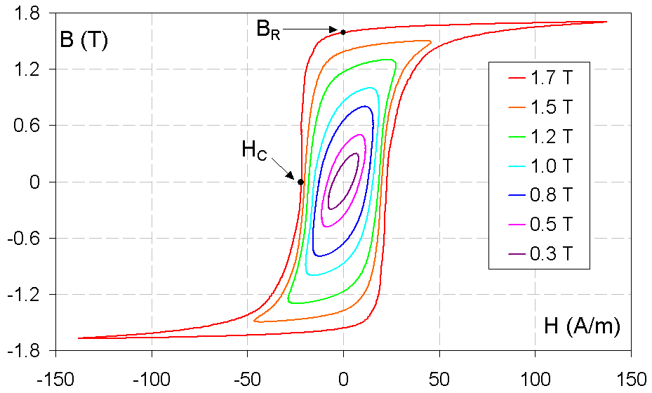
B(T) = Flux Density; H = magnetizing force

A family of hysteresis loops for grain-oriented electrical steel. B_{R}denotes retentivity and H_{C} is the coercivity. The wider the outside loop is, the higher the coercivity. Movement on the loops is counterclockwise. - “Wikipedia”

Force Relating two magnets in Equillibrium (using theory of magnet circuits)
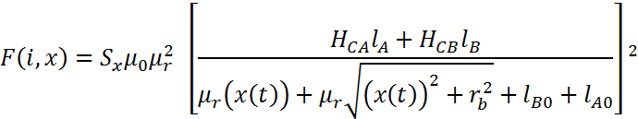
NOTE: Brackets should be squared;
Force Applied by One inductor in order to correct for instability (using theory of magnet circuits)
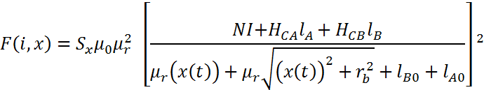
NOTE: Brackets should be squared;
I am not confident in these hand calculations since we are assuming a lot of factors to be true. A lot of adjustments would be needed, or a specialized computer program to calculate more accurate results.

